BHAVAN'S STUDENTS EXCEL IN CBSE CLASS X EXAM.
BOARD RESULT STD -X 2023
The Class X students of Bhavan's Bhagwandas Purohit Vídya Mandir, Civil Lines, Nagpur, have achieved stupendous results in the AISSE 2023. The students have once again produced exemplary results and maintained the school's trajectory of astounding results. Consistent efforts, unretiring will and perseverance from Principal, Teachers and Students, helped to achieve the present glory of the school.
Out of the 213 students who appeared for the exam,
81 students have scored 90% and above.
Yashasvi Saboo emerged the topper with 98.4%, followed by Priyanshi Panpaliya with 98.2%. The third position is shared by Anjali Zoting and Samruddhi Jain with 97.8% respectively.
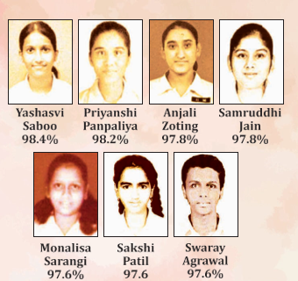
The subject wise toppers are as follows:

ENGLISH (100) | Rudrani Chandurkar
SANSKRIT (100) | Bhavik Chaudhary  Sarthak Jain  Ruchika Naukarkar  Monalisa Sarangi  Pranay Agrawal  Yashasvi 'Saboo  Shambhavi Dalvi  Samruddhi Jain  Shrunvat Pendke  Shubham Chandwani  Sakshi Patil
HINDI (98) | Akhil Ramteke
MARATHI (100) | Ananya Dhole  Krishna Duddalwar  Swaray Agrawal
SCIENCE (97) | Monalisa Sarangi  Pranay Agrawal  Sakshi Patil  Anaa Ahmed  Ameya Joge  Swaray Agrawal
MATHEMATICS (100) | Yashasvi Saboo  Samruddhi Jain  Poornima Pant  Swaray Agrawal
SOCIAL SCIENCE (100) | Yoggya Shrivastava

The Management, Principal Smt. Anju Bhutani and Staff congratulated the students for their efforts, which led to the excellent results, something which the school has been promoting and promising with each academic session.

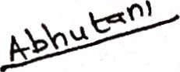

(SMT. ANJU BHUTANI)

PRINCIPAL
BHAVANS BHAGWANDAS PUROHIT VIDYA MANDIR
CIVIL LINES, NAGPUR 01
